企业微信配置官方文档:

<https://prometheus.io/docs/alerting/latest/configuration/#wechat_config>

配置企业微信注意事项：

[ to_user: [<string>](https://prometheus.io/docs/alerting/latest/configuration/#string) | default = '{{ template "wechat.default.to_user" . }}' ]

[ to_party: [<string>](https://prometheus.io/docs/alerting/latest/configuration/#string) | default = '{{ template "wechat.default.to_party" . }}' ]

[ to_tag: [<string>](https://prometheus.io/docs/alerting/latest/configuration/#string) | default = '{{ template "wechat.default.to_tag" . }}' ]

其中to_user、to_party、to_tag不能同时为空，必须有一个需要填上，一般填写to_party和to_tag

To_tag和to_party查看方式如下

To_tag：

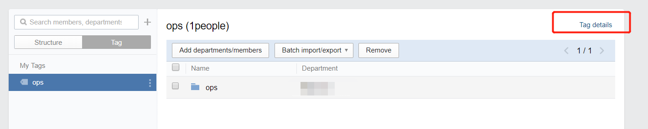

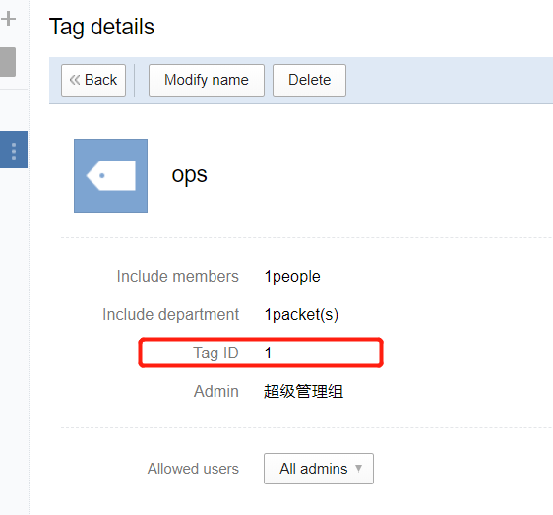

To_party：

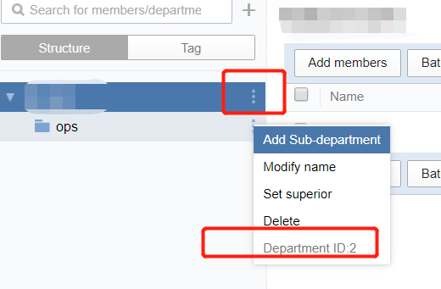

To_user:

